Left Patch   
  
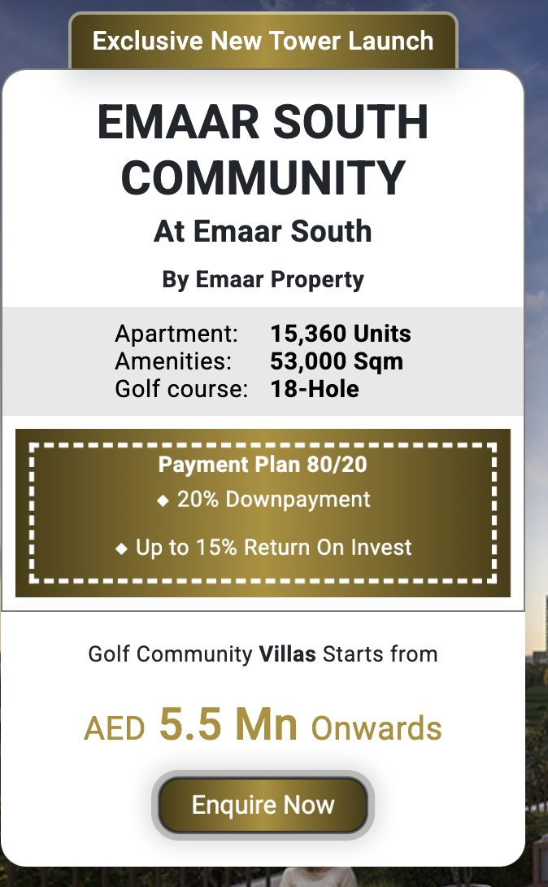  
  
Launching The Valley Phase 2  
  
Emaar Rivera The Valley   
At The Valley   
By Emaar Properties  
  
Villas - 378  
Possession - 2028  
  
10% Down Payment   
80% During Construction   
10% On handover  
  
Semi-Detached Villas Starts From   
AED 4.85 Mn Onwards  
  
  
  
  
About Emaar Rivera The Valley  
  
Emaar Properties introduces Rivera at The Valley, an exceptional residential enclave offering a select range of 3 and 4-bedroom townhouses. Nestled in a serene, nature-infused community, this limited collection of just 378 homes seamlessly blends contemporary sophistication with the peace of expansive green landscapes. Anticipated for completion in the fourth quarter of 2028, Rivera is designed to be a sanctuary of modern living amidst nature's embrace.

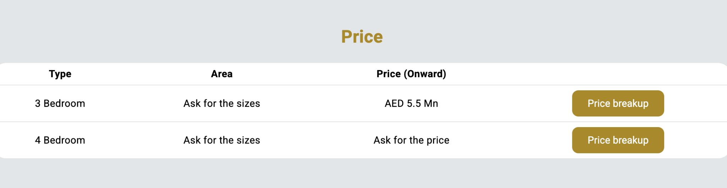

Type Area Price(onwards)

4 Bedroom 3,700 sqft AED 4.5 Mn  
  
  
Location - https://maps.app.goo.gl/VPRkqADeN2bqK2ZCA